Project Design Phase-II
Solution Requirements (Functional & Non-functional)

Date | 15 February 2026
Team ID | LTVIP2026TMIDS24181
Project Name | ToyCraft Tales – Tableau’s Vision into Toy Manufacturer Data
Maximum Marks | 4 Marks

Functional Requirements:
Following are the functional requirements of the proposed solution.
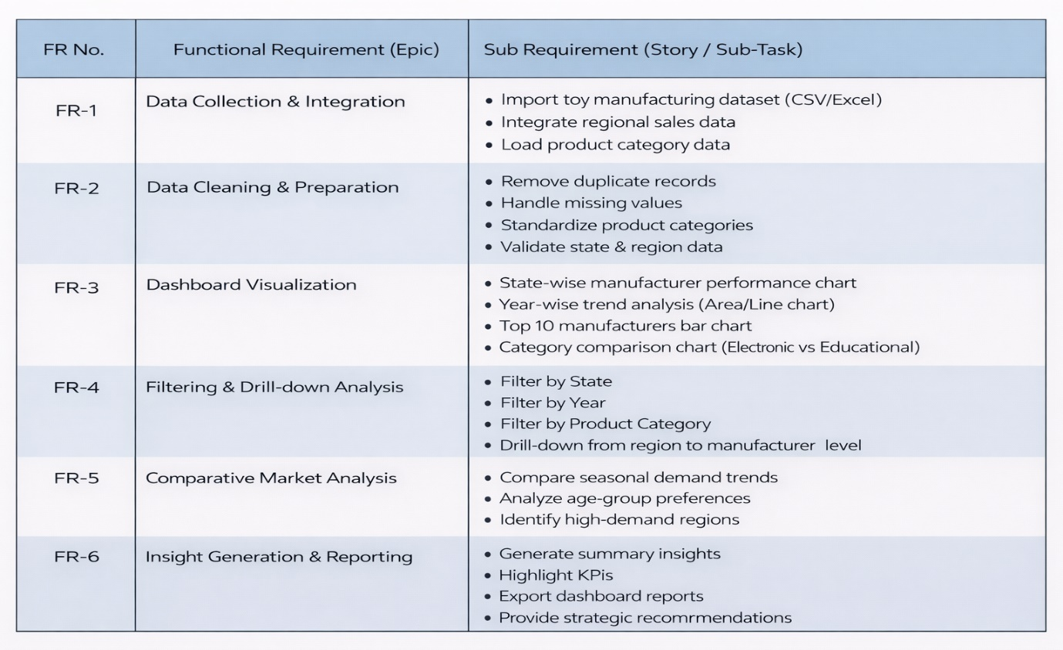

Non-functional Requirements:
Following are the non-functional requirements of the proposed solution.
FR No. | Non-Functional Requirement | Description
NFR-1 | Usability | System ensures high usability standards.
NFR-2 | Security | System ensures high security standards.
NFR-3 | Reliability | System ensures high reliability standards.
NFR-4 | Performance | System ensures high performance standards.
NFR-5 | Availability | System ensures high availability standards.
NFR-6 | Scalability | System ensures high scalability standards.

